**TEMASEK POLYTECHNIC**

**SCHOOL OF INFORMATICS & IT**

**DIPLOMA IN IMMERSIVE MEDIA & GAME DEVELOPMENT**

**AY2024/2025 OCTOBER SEMESTER**

**GADV (CGE2C25)**

**Unity Animation System**

To see the additional comments and resources, make sure you select **All Markup** in the **Review/Tracking** pane

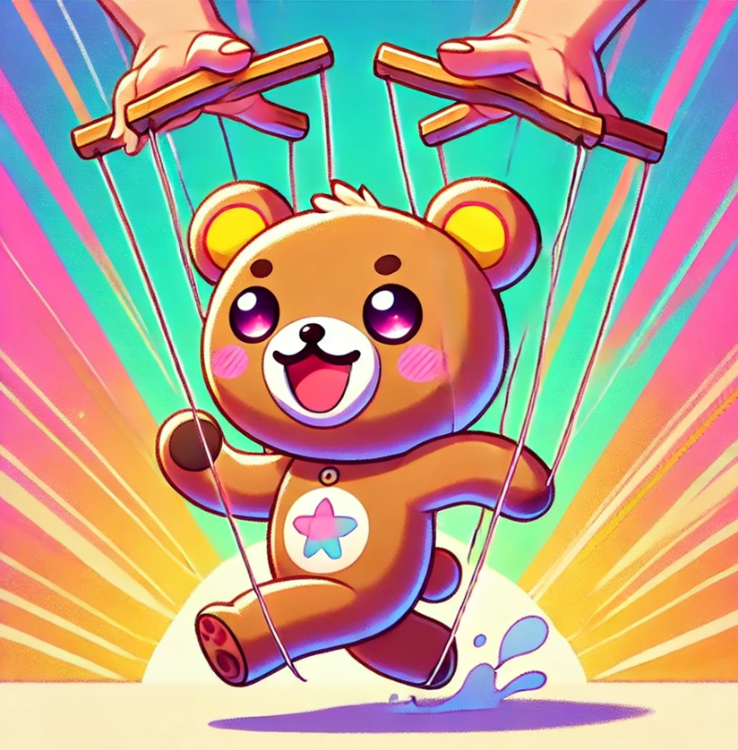

This worksheet will introduce you to the basics of Unity's animation system for 3D characters using C#. Throughout this worksheet, you will learn essential concepts and techniques to create and control animations in Unity.

We will cover topics such as downloading and importing 3D characters from Mixamo, setting up animation controllers, importing animations, and implementing basic character control through keyboard input.

By understanding and mastering these concepts, you will be able to create dynamic and interactive animations for your 3D characters in Unity. This knowledge will empower you to design more engaging and immersive games and interactive experiences.

Have fun! 😊

**Part 1: Downloading and Importing from Mixamo**

In this part of the worksheet, you’ll to download a 3D character from the Mixamo website and import it into Unity.

Mixamo is a platform from Adobe that offers a wide range of ready-to-use 3D characters and animations. It's a great resource for game developers!

First:

* Create a folder called **3D_Animation** in your **GADV_Worksheets** project.
* Add the usual sub-folders (Scenes, Scripts).
* Create a new scene, and save it as **3D_Animation** inside Scenes.

**Step 1: Browsing and Selecting a Character**

1. Open your web browser and go to [**https://www.mixamo.com/**](https://www.mixamo.com/).
2. Browse through the character library and find the **Y Bot** character (below).

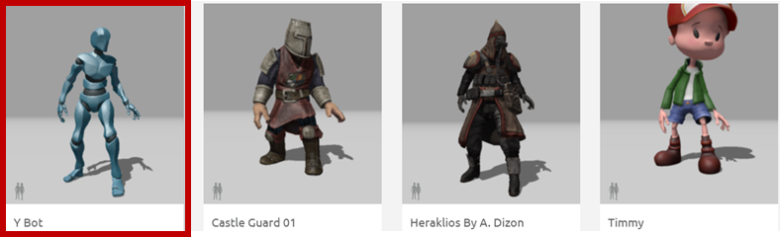

1. Click on the character to view it in 3D.

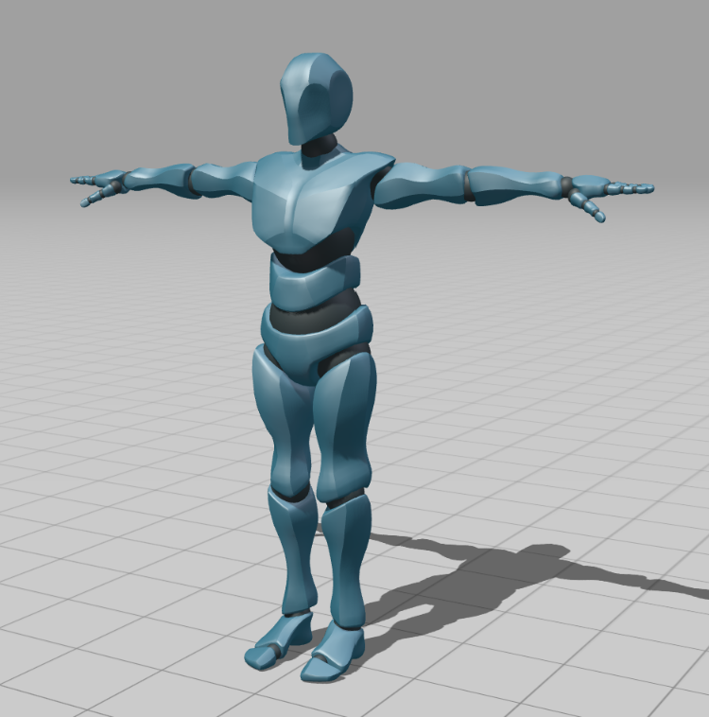

**Step 2: Downloading the Character as an FBX File**

1. Click on the "Download" button.
2. In the download options, select "FBX for Unity" as the file format.
3. Choose T-Pose.
4. Click on the "Download" button to save the character's FBX file to your computer.

**Step 3: Importing the Character into Unity**

1. Go back to Unity, and create this folder structure:

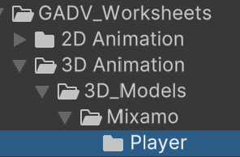

1. In the Unity Editor, go to the "Assets" menu and select "Import New Asset" to open the file browser.
2. Locate and select the downloaded FBX file.

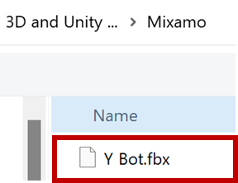

1. Click on the "Import" button to import the character into Unity and save it in **3D_Models/Mixamo/Player**.

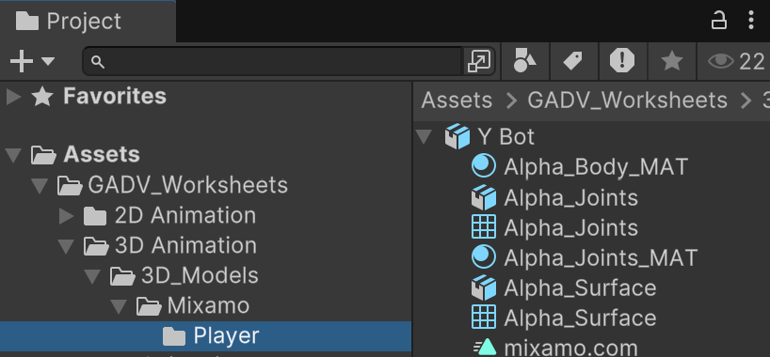

The **Y Bot** FBX file contains the following components:

* **Model** – The 3D mesh of the character.
* **Rig** – The skeletal structure for animations.
* **Materials** – Defines the surface appearance (Alpha_Body_MAT, Alpha_Joints_MAT).
* **Meshes** – The separate geometry parts (Alpha_Joints, Alpha_Surface).
* **Mixamo Metadata** – Includes references for rigging data.

1. Click on the asset, then on the **Rig** button, and then set the Rig animation type to **Humanoid**, then scroll down and click **Apply**.

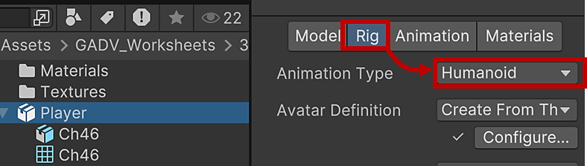 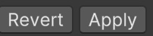

This makes the character rig compatible with any Unity animation for humanoid characters.

1. Drag an instance of the Y Bot to the Scene view.

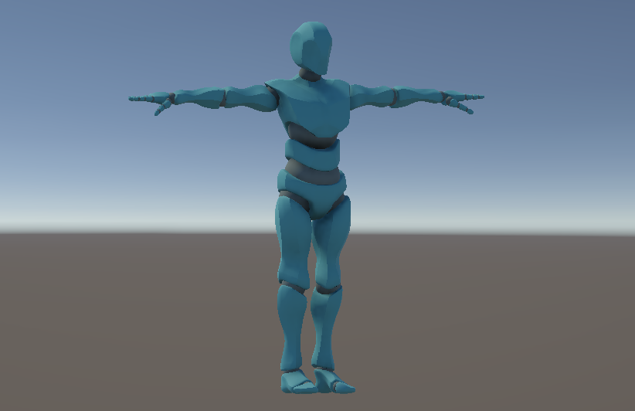

Congratulations! You have successfully downloaded a 3D character from Mixamo and imported it into Unity.

In the next part, we will explore how to add animations to the character.

**Part 2: Downloading Animations from Mixamo**

In this part of the worksheet, we will learn how to download *animations* from Mixamo and import them into Unity.

**Step 1: Downloading Animations from Mixamo**

1. Go to mixamo.
2. Select Y Bot again.
3. Click the **Animations** button at the top of the page.



1. Browse through the animation library.
2. Find an **Idle** animation and view its details. Play around with the animation parameters to see what they do.

 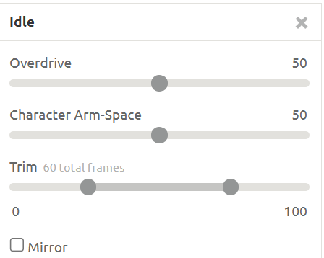

**Step 2: Importing Animations into Unity**

1. Once you've chosen an animation, click the "Download" button.
2. In the download options, leave the settings (e.g., format, keyframe reduction) as shown here:

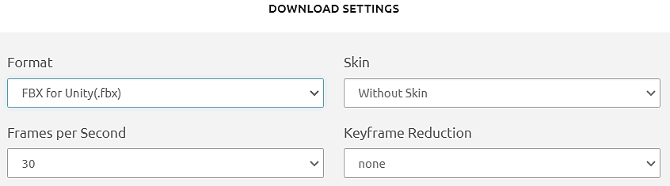

We already have the FBX model that was downloaded earlier, so we don’t need an FBX skin (3D mesh) for the animation.

1. Click the "Download" button to save the animation file to your computer. Note that this is a FBX file, with the same name as the animation, e.g., **Idle.fbx**. You’ll see soon that the actual animation is stored as part of this FBX file:

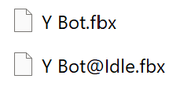

1. Go back to your Unity project and create a new folder in Assets called **Animations**.
2. In the Unity Editor, right-click *inside* the Animations folder..
3. Select "Import New Asset" to open the file browser.
4. Locate and select the downloaded animation file.
5. Click "Import" to import the animation into Unity in the Animations folder.

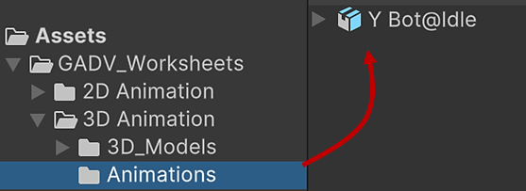

**Step 3: Configuring Animation Clips and Settings**

1. In the Project window, locate the imported animation file.
2. Click on the animation file to view its details in the Inspector window.
3. Click the **Edit** button.
4. Click the **Rig** button, then ensure the **Rig Animation Type** is set to "Humanoid" (the other main type is "Generic", but since this is a character, set it to Humanoid, just like you did in the previous section when you imported the character FBX file).
5. Set the **Avatar Definition** to “Copy From Other Avatar”.
6. Set the **Source** to the avatar for the character imported earlier, **Y BotAvatar**.

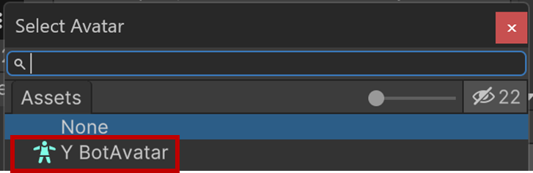

1. Click the **Animation** button to configure other animation settings, such as loop time, import scale, and rig.
2. Click the "Apply" button to apply the changes.

Now go back to Mixamo. Look for, and then download and import the **Running**, **Running** **Jump**, and **Fall Flat** animations shown below:

  

You can select multiple assets to import at once:

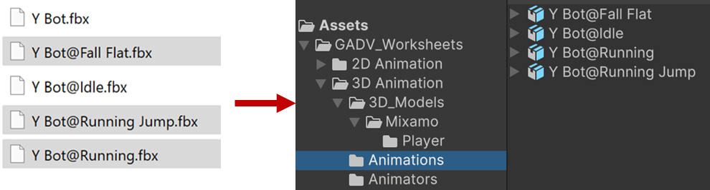

Remember to configure the rig for each animation, as before. You can do this to multiple animations at the same time:

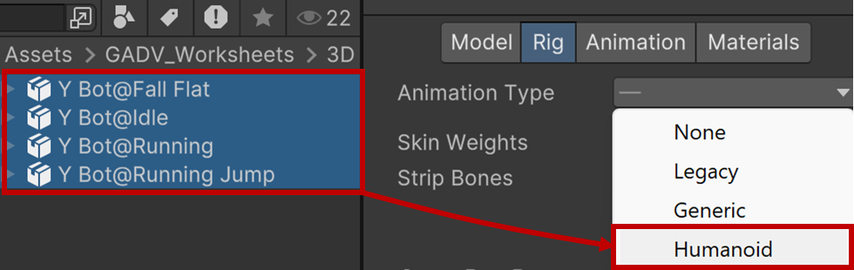

Remember to click **Apply**!

**Part 3: Understanding Animator Controllers**

In this part of the worksheet, we’ll explore animation controllers and learn how to create one for our character in Unity.

**Step 1: Introduction to Animator Controllers**

**Animator controllers** are essential for managing and controlling animations in Unity. They allow us to define the logic for transitioning between different animations based on specific conditions or triggers.

**Step 2: Creating an Animation Controller**

1. Create a new folder in Assets called **Animators**.
2. In the Unity Editor, navigate to the "Project" window.
3. Right-click in the **Animators** folder and select "Create > Animator Controller."
4. Give the new controller a name, such as "CharacterAnimator."

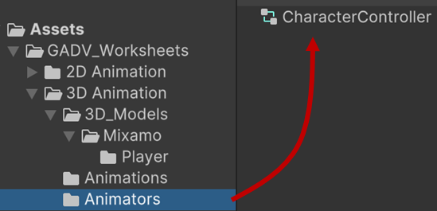

1. Double-click the newly created controller to open it in the Animator window.

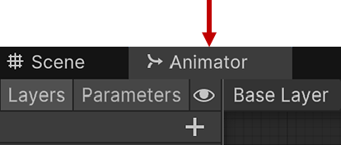

**Step 3: Configuring Animation Transitions and Parameters**

1. In the Animator window, you will see a blank canvas representing the animation controller.
2. To add animations, drag and drop the animations you imported earlier onto the Animator canvas.

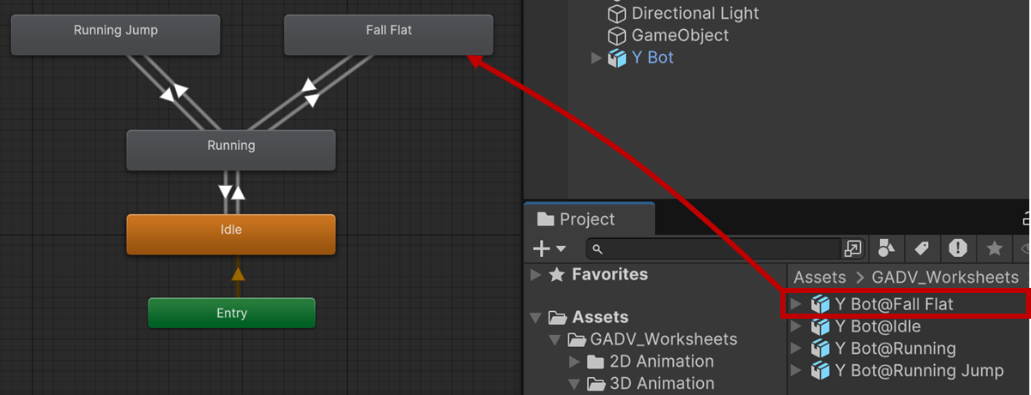

1. Connect the animations by creating transitions between them.
   1. Right click on an animation and drag the arrow to another animation to create a new transition.

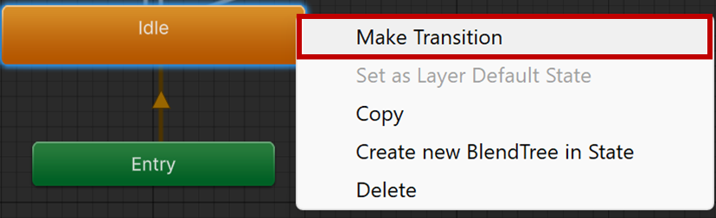

The Animator should look like this:

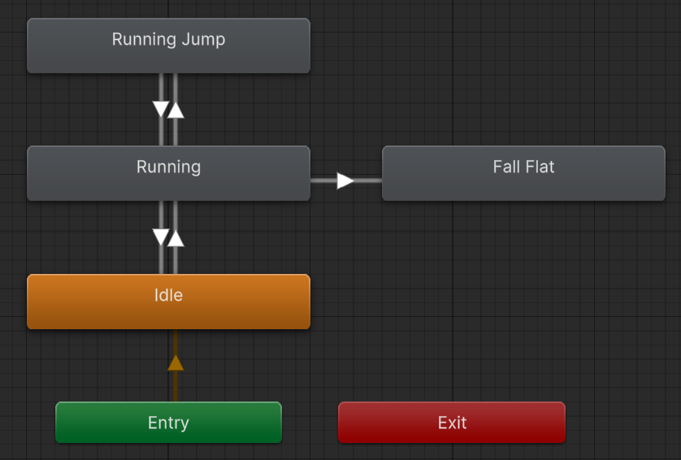

1. Define **parameters** to control the transitions.
2. Click on the "+" button in the "Parameters" section of the Animator window.
3. Add the following parameters:

**Run: Bool**

**Jump: Trigger**

**Fall: Trigger**

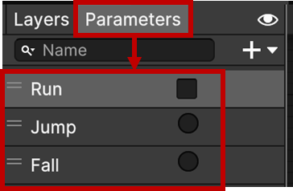

1. Now set up the transition conditions.
2. Click the arrow from Idle to Running.
3. In the Inspector, set the condition as below.

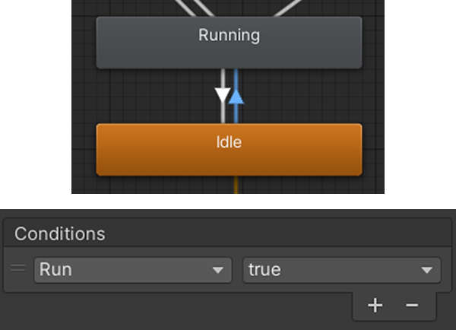

This means that the animation state will change from Idle to Running when the **Run** boolean parameter value is **true**.

1. Set the transition condition for *Running to Idle* to **Run** is **false**.

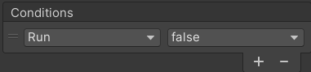

1. Set the condition for *Running to Jump* to **Jump** (no true or false is needed, since this is a trigger that just fires once).
2. Don’t set any condition for *Jump to Running*, since this should happen once the Jump animation has ended.
3. Set up the **Fall** animation in a similar way (you should be able to figure it out). Don’t add a transition back to Running, since we’ll just leave the player lying on the ground. Look at the diagram above for guidance.

**Step 4: Testing the Animation Controller**

Now, we’ll test that everything is ok before setting up the actual character.

1. Add an empty game object to the scene.
2. Add an **Animator** component to it.
3. Drag the CharacterAnimator you just created into the Controller slot in the Inspector.
4. Press the Play button at the top of the Unity Editor to test the animations.
5. Click the various parameters on and off in the Animator panel and watch as the different animations are activated. Note that when you click Fall, the animation state will change to Fall, and then stay there since there is no transition out of Fall.



**Step 5: Setting up the Character**

1. Delete the empty test game object.
2. Drag the Y-Bot character into the scene and set its position to (0,0,0).

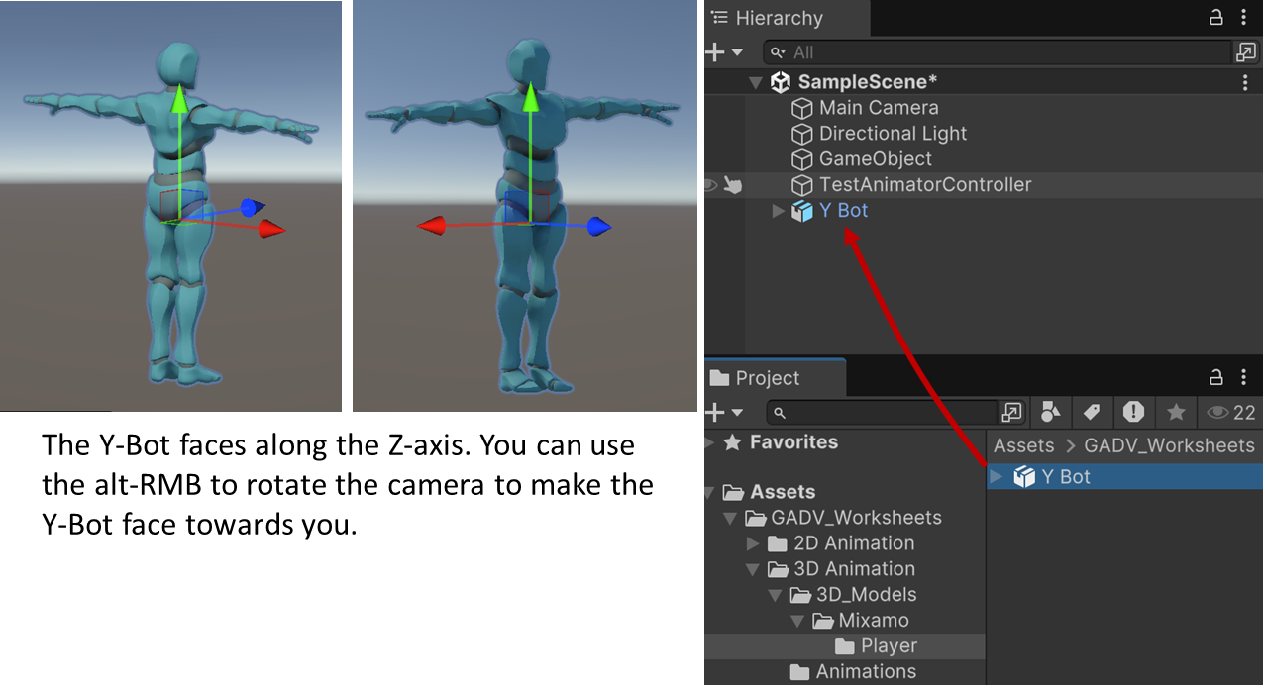

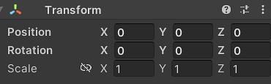

1. Add an Animator component.

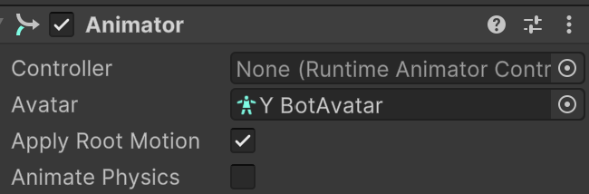

1. Drag the **CharacterAnimator** you just created into the **Controller** slot.

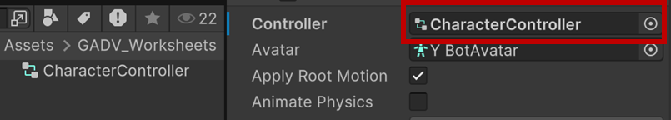

1. Click on the various parameters to see how the different animations play.

When you activate Run, the character will run off-screen!

This because something called **Root Motion** is activated. To switch this off, click on the character in the Hierarchy, find the Animator component in the Inspector, and uncheck Apply Root Motion. All character animations will now run on the spot.

Great work! You have successfully downloaded animations from Mixamo and added them to your character in Unity. In the next part, we will explore how to set up animation *events*. Keep up the good work. Hopefully you find this interesting!

**Part 5: Setting Up Animation Events**

Now, we will learn how to set up animation events in Unity.

Animation events allow us to trigger actions or execute code at specific points during an animation.

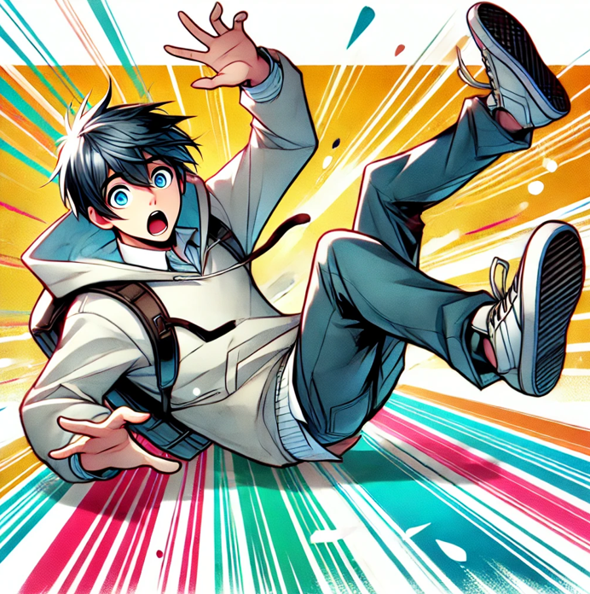

**Step 1: Introduction to Animation Events**

Animation events are markers placed at specific frames in an animation timeline.

These events can be used to call functions or perform actions, adding interactivity to our animations.

First, we will focus on adding an animation event to the **Fall** animation.

This animation event will trigger a specific action, such as printing a text message to the console or (usually) making something happen in your game.

Here's what you need to do:

1. Double-click the Fall animation state in the Animator window. This will show the Animation in the Inspector.

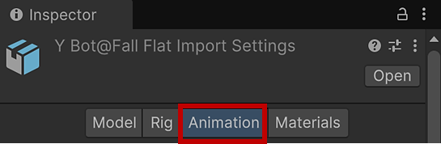

1. Scroll down to **Events** at the bottom.

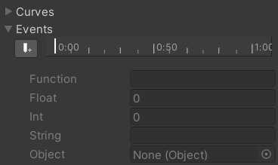

1. Open the **animation preview panel** in the Inspector.



**Pull up if you can’t see the animation preview panel**

1. Scrub through the timeline in the animation preview window, and find the end of the Fall Flat animation.



**Scrubbing the timeline here will also scrub the Events timeline.**

1. Right-click on the Animation Timeline at the desired end time and choose "Add Animation Event" from the context menu.

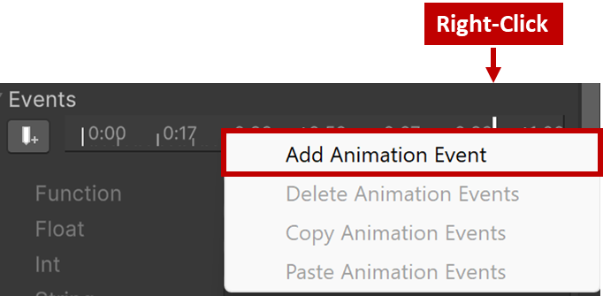

1. A new animation event marker will appear at the selected time.
2. Click on the animation event marker to open the event details.
3. In the "Function" field, enter the name of the method that will handle the event (e.g., "HandleFall").

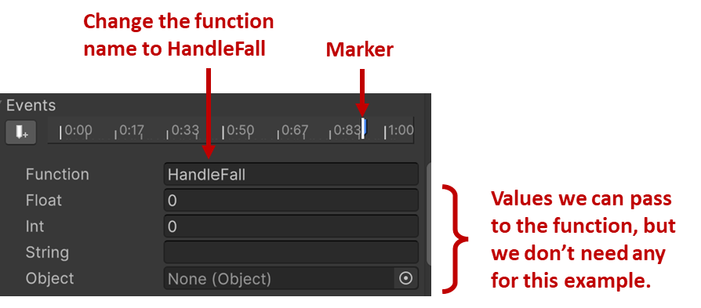

1. Click **Apply** to save the changes to the animation.

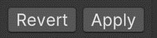

1. Now, open your code editor, create a new script called **PlayerController**, then add the following code:

using UnityEngine;

public class PlayerController : MonoBehaviour

{

private Animator animator;

private void Start()

{

animator = GetComponent<Animator>();

}

// Animation event handler method

public void HandleFall()

{

Debug.Log("Oof! I didn't expect that!");

}

}

1. Save the script and add it to the player as a component.
2. Run the project, then in the Animator click with your mouse to activate the Fall trigger to make the player character fall over.

Once the animation reaches the animation event position in the animation’s timeline, the message should be printed to the console.

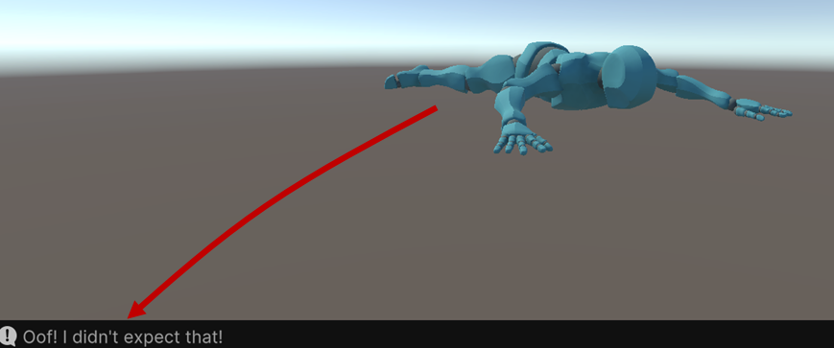

By completing this part of the worksheet, you have added an animation event to the Fall animation.

When the animation reaches the specified time, the method `HadleFall` will be invoked, which will print the message "Oof! I didn't expect that!" to the console.

This allows you to add custom actions or functionality based on specific events in your animations.

**Part 6: Implementing Keyboard Input for Animation Control**

In this part of the worksheet, we will focus on controlling the animations of the Player game object using code. The Player object has an animator controller with Idle, Running, Jump, and Fall animations. The animator controller has the following parameters: Running (Bool), Jump (Trigger), and Fall (Trigger).

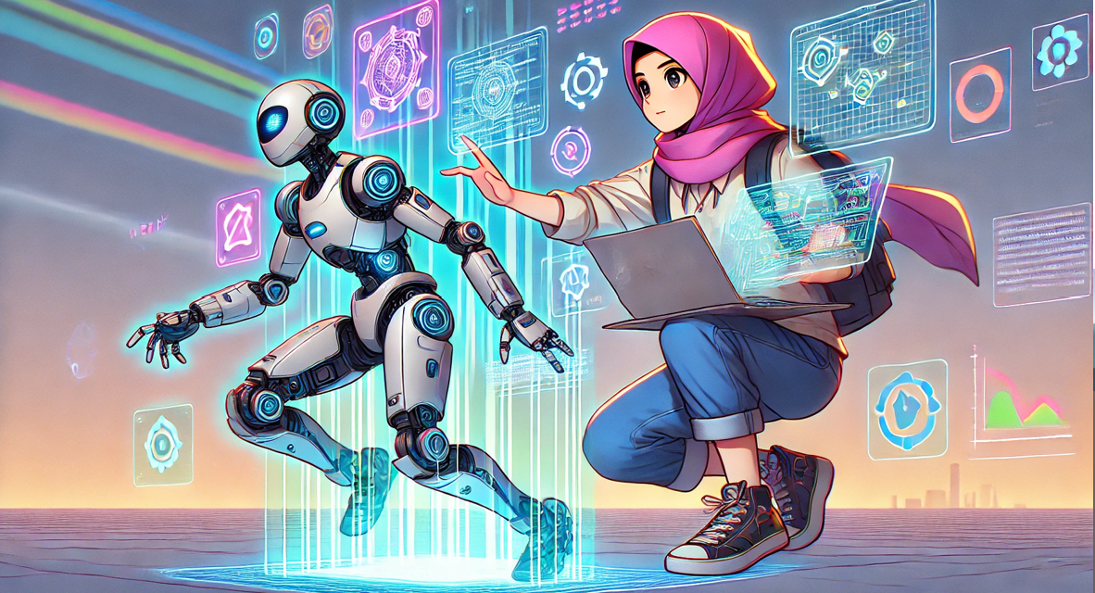

Here's what you need to do:

1. Open and edit your **PlayerController** script.
2. Implement the code to control the animations based on specific conditions. Here are some examples:

using UnityEngine;

public class PlayerController : MonoBehaviour

{

private Animator animator;

bool isRunning;

private void Start()

{

animator = GetComponent<Animator>();

}

// Animation event handler method

public void HandleFall()

{

Debug.Log("Oof! I didn't expect that!");

}

private void Update()

{

// Example 1: Transition to Running animation

isRunning = true;

animator.SetBool("Run", isRunning);

// Example 2: Trigger the Jump animation

if (Input.GetKeyDown(KeyCode.Space))

{

animator.SetTrigger("Jump");

}

// Example 3: Trigger the Fall animation

if (Input.GetKeyDown(KeyCode.F)

{

animator.SetTrigger("Fall");

}

}

}

1. Customize the code according to your specific conditions and input controls. You can add additional conditions and triggers as needed.

By completing this part of the worksheet, you will be able to write code to control the transitions between the Idle, Running, Jump, and Hit On Legs animations of the Player game object based on different conditions and input controls.

**Part 7: Summary and Conclusion**

Congratulations! You have reached the final part of the worksheet. In this section, we will summarise what we've learned throughout the tutorial on Unity animation system for 3D characters with C#.

Let's recap the key points.

1. **Importing the Character from Mixamo**

We learned how to download a 3D character and various animations from Mixamo and import these into Unity.

1. **Understanding Animation Controllers**

We explored the concept of animation controllers and how they help manage and control animations in Unity.

1. **Adding Animations to the Character**

We learned how to import animations into Unity and connect them using an animation controller.

1. **Setting Up Animation Events**

We discovered how to set up animation events at specific points in the animation timeline to trigger actions or execute code.

1. **Implementing Keyboard Input for Animation Control**

We learned how to use the Input Manager to define input axes and implemented keyboard input to control animations based on user interaction.

By following this worksheet, you have gained valuable knowledge and practical experience in using Unity's animation system with C#. You can now create interactive and dynamic animations for your 3D characters.

Remember, this worksheet covered the foundational aspects of Unity animation system, but there is still much more to explore and learn. Continue practicing, experimenting, and expanding your skills to create even more impressive and engaging animations.

Well done on completing the worksheet!

If you have any questions or need further assistance, ask your tutor!

Happy animating! 😊